|  |
| --- |
| Azure solution for Pharmaceuticals |
| Azure Data Services | Pharmaceutical | Hands-on experience |



Microsoft Advanced Analytics lab

Big Data and Analytics for Pharmaceuticals

Contents

Presentation and objective 3

Part 1: Create an Azure SQL Database to store Clinical data 4

Description of the service 4

Steps to create the Azure SQL Server 4

Steps to create the Azure Database 8

Steps to create the Database Schema 10

Part 2: Create the Blob storage as a landing zone to Azure 15

Description of the service 15

About Blob storage 15

Steps to create the Azure Blob storage 15

Steps to create the Azure Blob storage container 20

Part 3 Feeding the Data Warehouse with Azure Data Factory 23

Description of the service 23

Steps to create the Azure Data Factory 23

Steps to create the Azure Data Factory pipeline 25

# Presentation and objective

The goal of this lab is to give you a technical glimpse of the Azure Data Platform, especially how to ingest and orchestrate data movement.

The diagram below represents the solution we will build. The folder “Data Ingestion Lab.zip” contains all the materials needed for this lab



# Part 1: Create an Azure SQL Database to store Clinical data

## Description of the service

SQL Database is a relational database service in the Microsoft cloud based on the market-leading Microsoft SQL Server engine and capable of handling mission-critical workloads. SQL Database delivers predictable performance at multiple service levels, dynamic scalability with no downtime, built-in business continuity, and data protection — all with near-zero administration. These capabilities allow you to focus on rapid app development and accelerating your time to market, rather than allocating precious time and resources to managing virtual machines and infrastructure. Because SQL Database is based on the SQL Server engine, SQL Database supports existing SQL Server tools, libraries, and APIs. As a result, it is easy for you to develop new solutions, to move your existing SQL Server solutions, and to extend your existing SQL Server solutions to the Microsoft cloud without having to learn new skills

## Steps to create the Azure SQL Server

1. On the upper left side of the portal, click on create “plus sign” Create a resource
2. Search for SQL Server
3. Choose the SQL Server (logical Server)
4. Fill the configuration page like below with your **own information**. (sever name, login, pwd,…). **Please not this information for later.**

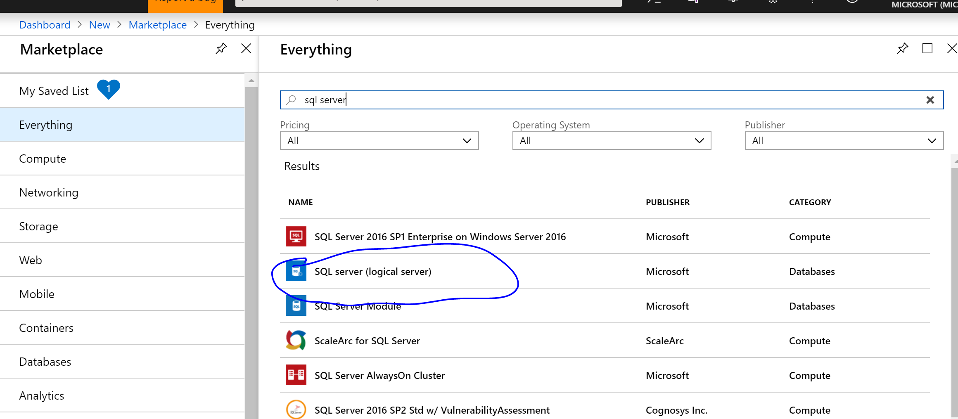

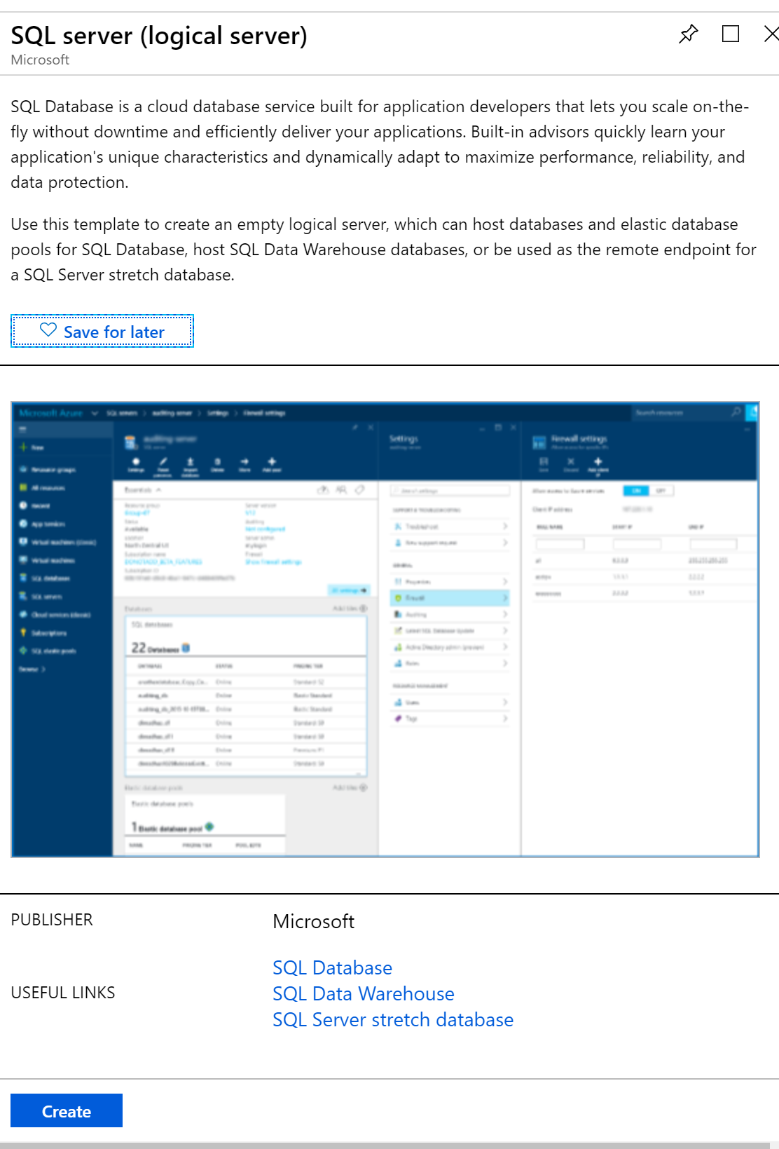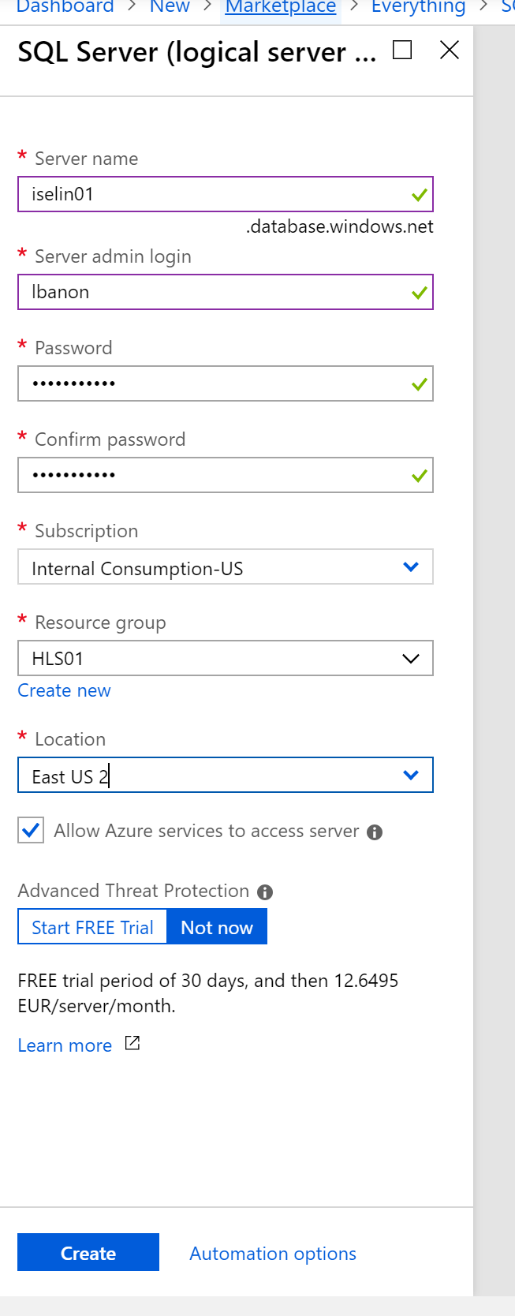

## Steps to create the Azure Database

1. On the upper left side of the portal, click on create “All Services”
2. Scroll to find for SQL Server
3. Select the SQL Server, you have just created
4. On the upper right screen, select New Database
5. Fill the configuration page like below with your **own information**. **Please not this information for later.**

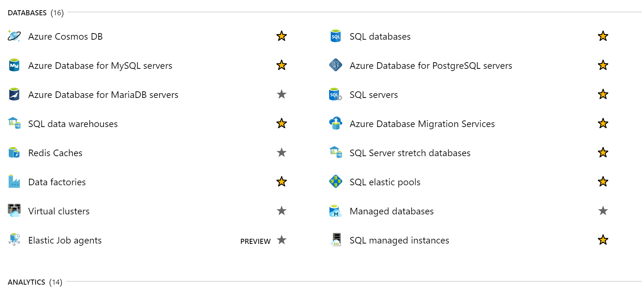

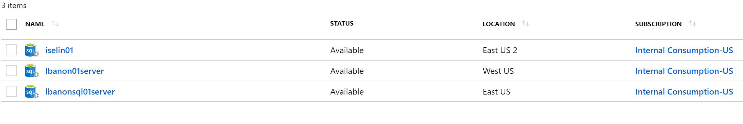

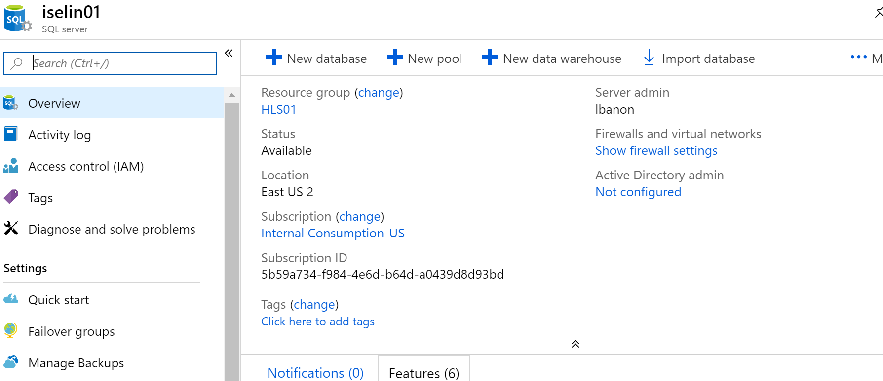

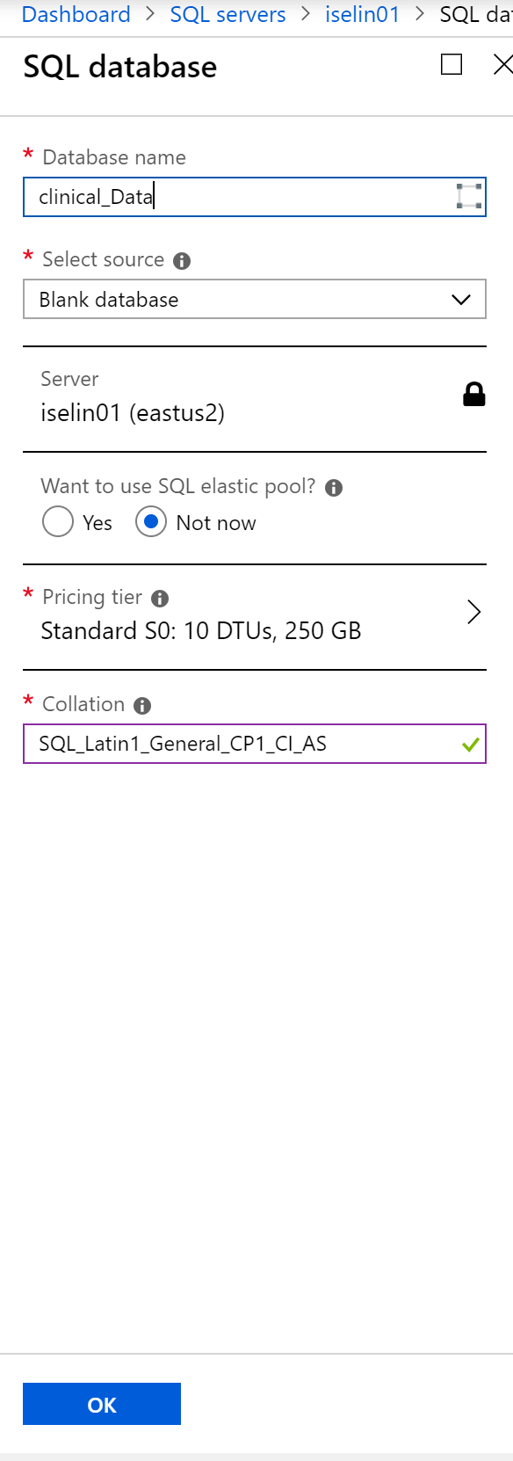

## Steps to create the Database Schema

1. On the Database list, select the Database you have just created
2. On the left pane, click on “the querying Editor”
3. Import the ClinicalData.sql script and run it. It will create

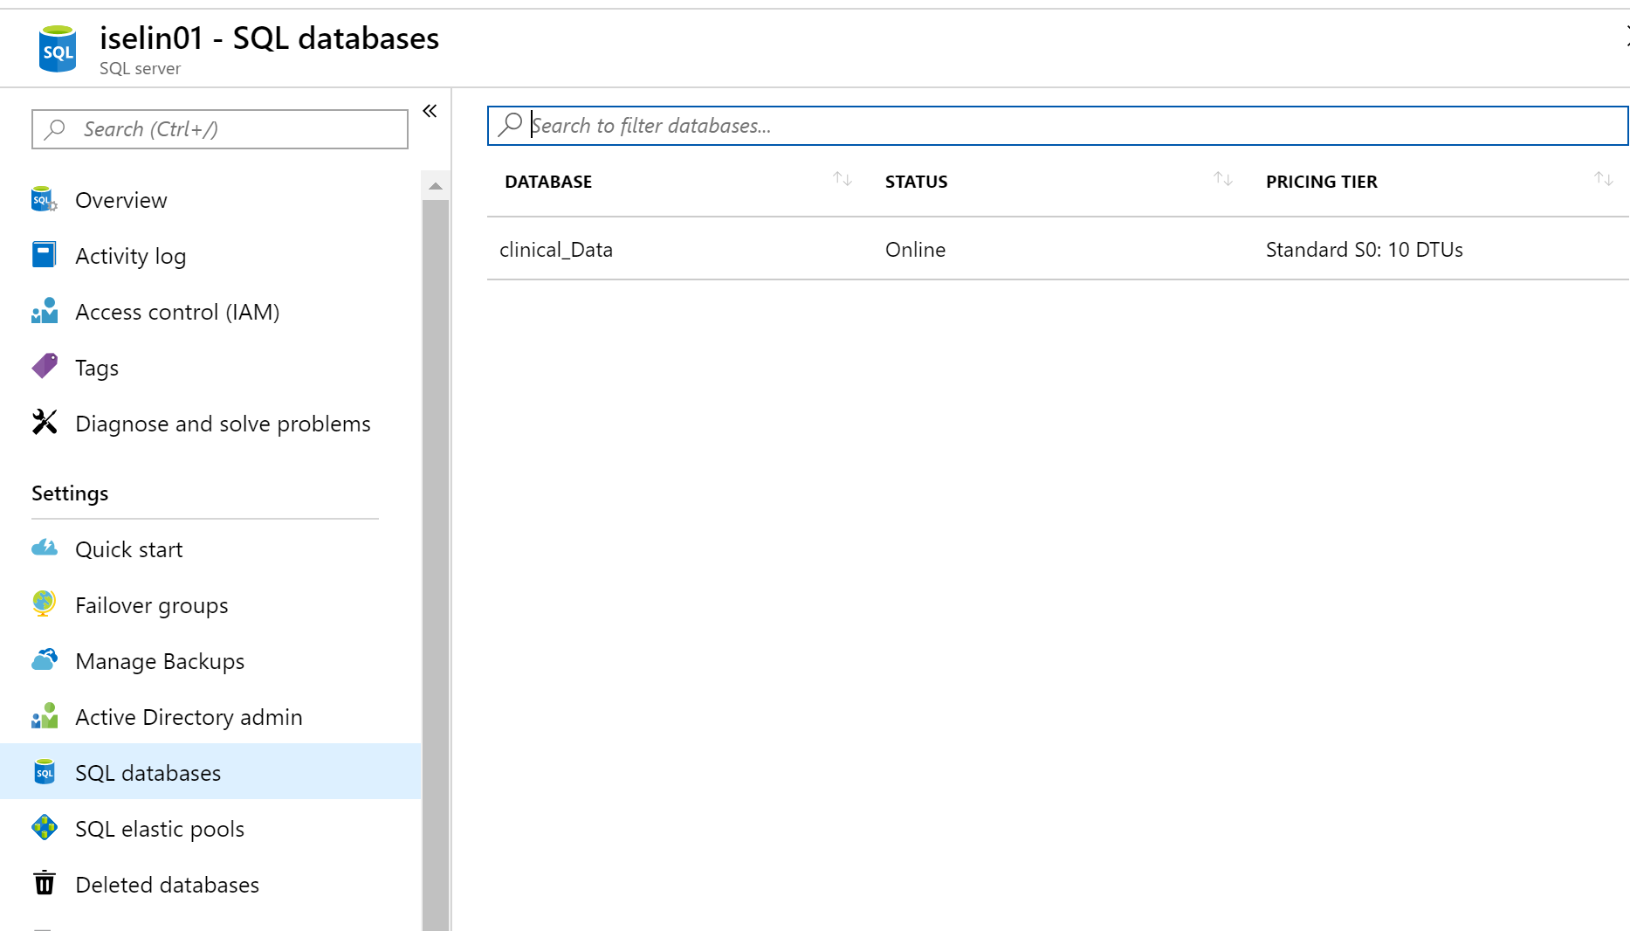

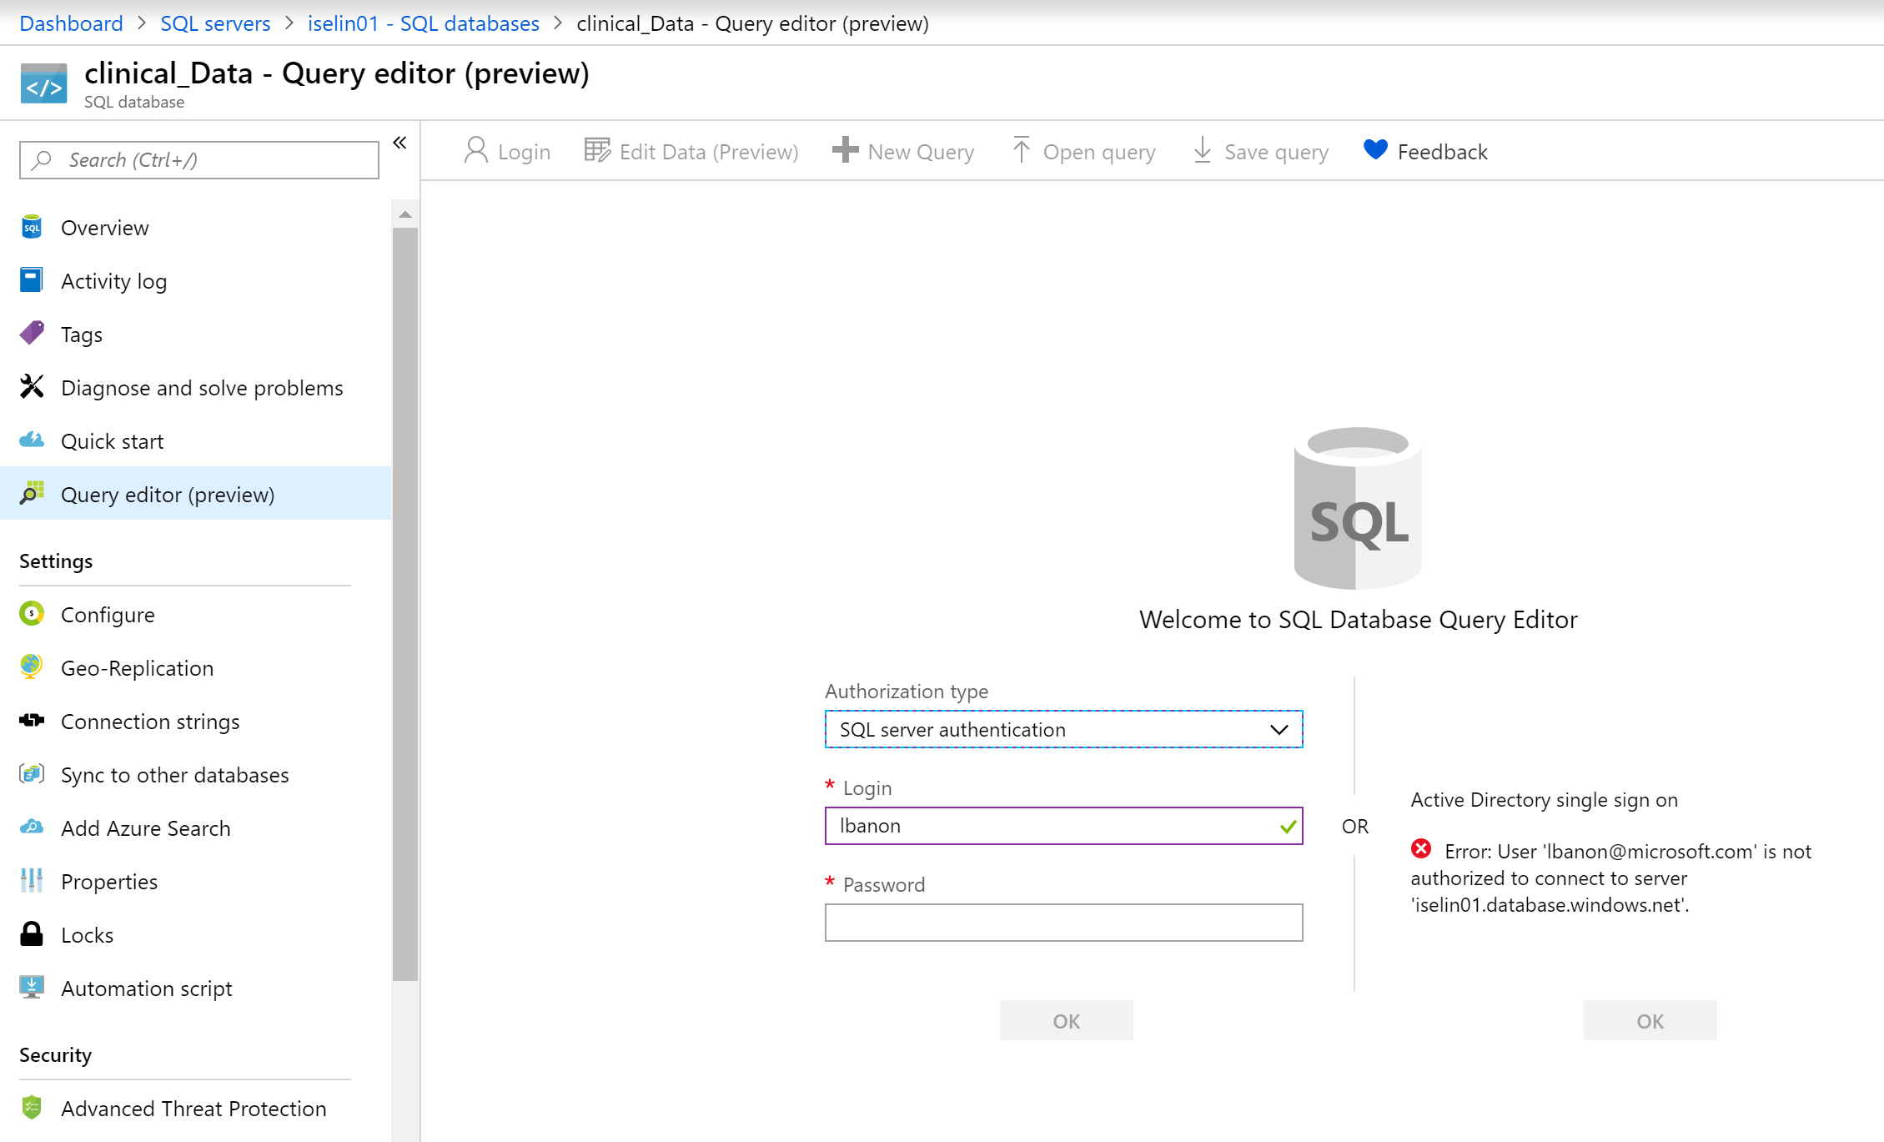

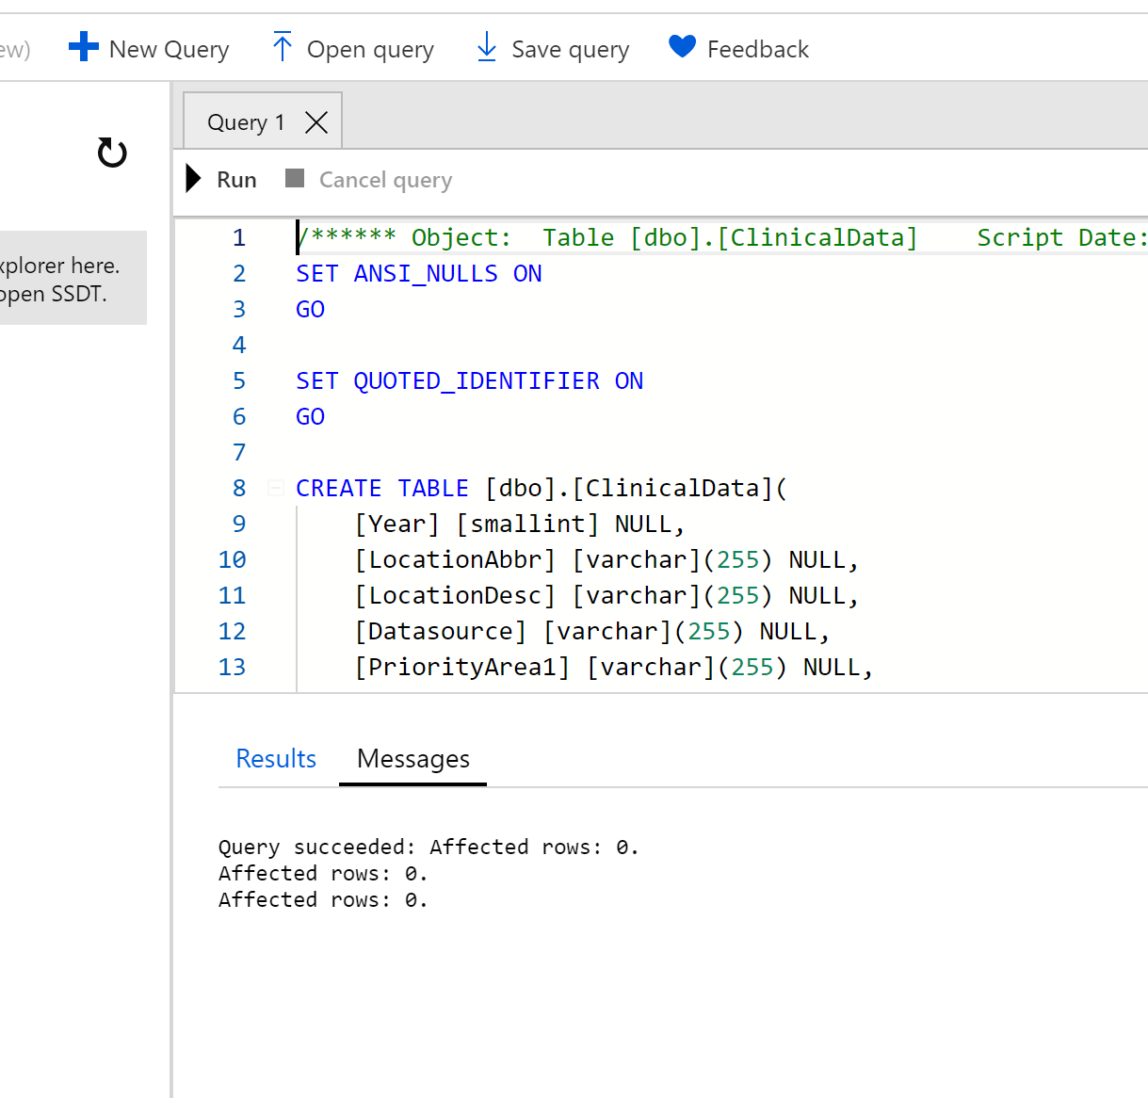

# Part 2: Create the Blob storage as a landing zone to Azure

## Description of the service

Azure Blob storage is Microsoft's object storage solution for the cloud. Blob storage is optimized for storing massive amounts of unstructured data. Unstructured data is data that does not adhere to a particular data model or definition, such as text or binary data.

About Blob storage

Blob storage is designed for:

* Serving images or documents directly to a browser.
* Storing files for distributed access.
* Streaming video and audio.
* Writing to log files.
* Storing data for backup and restore, disaster recovery, and archiving.
* Storing data for analysis by an on-premises or Azure-hosted service.

Users or client applications can access objects in Blob storage via HTTP/HTTPS, from anywhere in the world. Objects in Blob storage are accessible via the [Azure Storage REST API](https://docs.microsoft.com/rest/api/storageservices/blob-service-rest-api), [Azure PowerShell](https://docs.microsoft.com/powershell/module/azure.storage), [Azure CLI](https://docs.microsoft.com/cli/azure/storage), or an Azure Storage client library. Client libraries are available for a variety of languages, including [.NET](https://docs.microsoft.com/dotnet/api/overview/azure/storage/client), [Java](https://docs.microsoft.com/java/api/overview/azure/storage/client), [Node.js](http://azure.github.io/azure-storage-node), [Python](https://docs.microsoft.com/python/azure/), [Go](https://github.com/azure/azure-storage-blob-go/), [PHP](http://azure.github.io/azure-storage-php/), and [Ruby](http://azure.github.io/azure-storage-ruby).

## Steps to create the Azure Blob storage

1. On the upper left side of the portal, click on create “All Services”
2. Search to find “Storage”
3. Select “Storage account”
4. On the upper left screen, select the “plus sign” to create a new storage
5. Fill the configuration page like below with your **own information**. **Please not this information for later.**

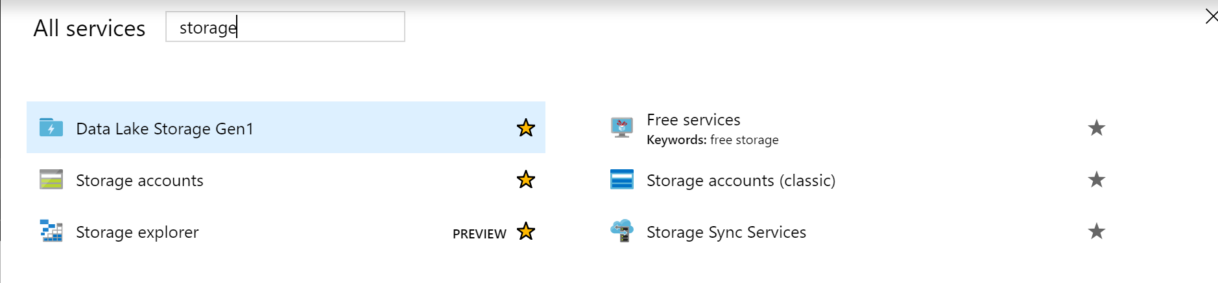

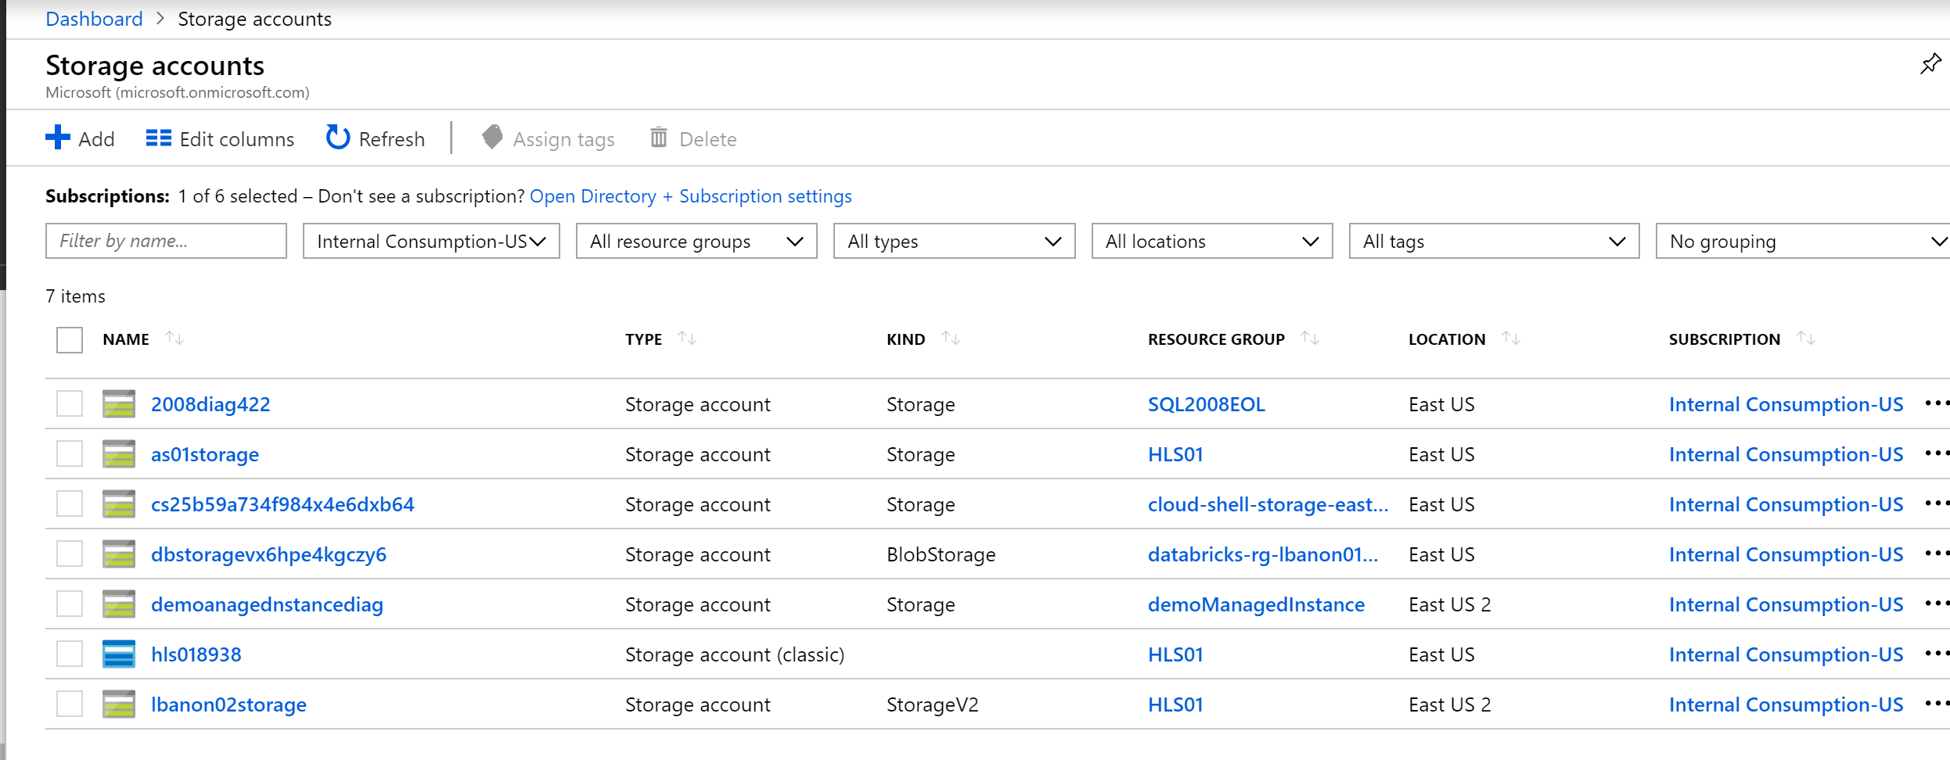

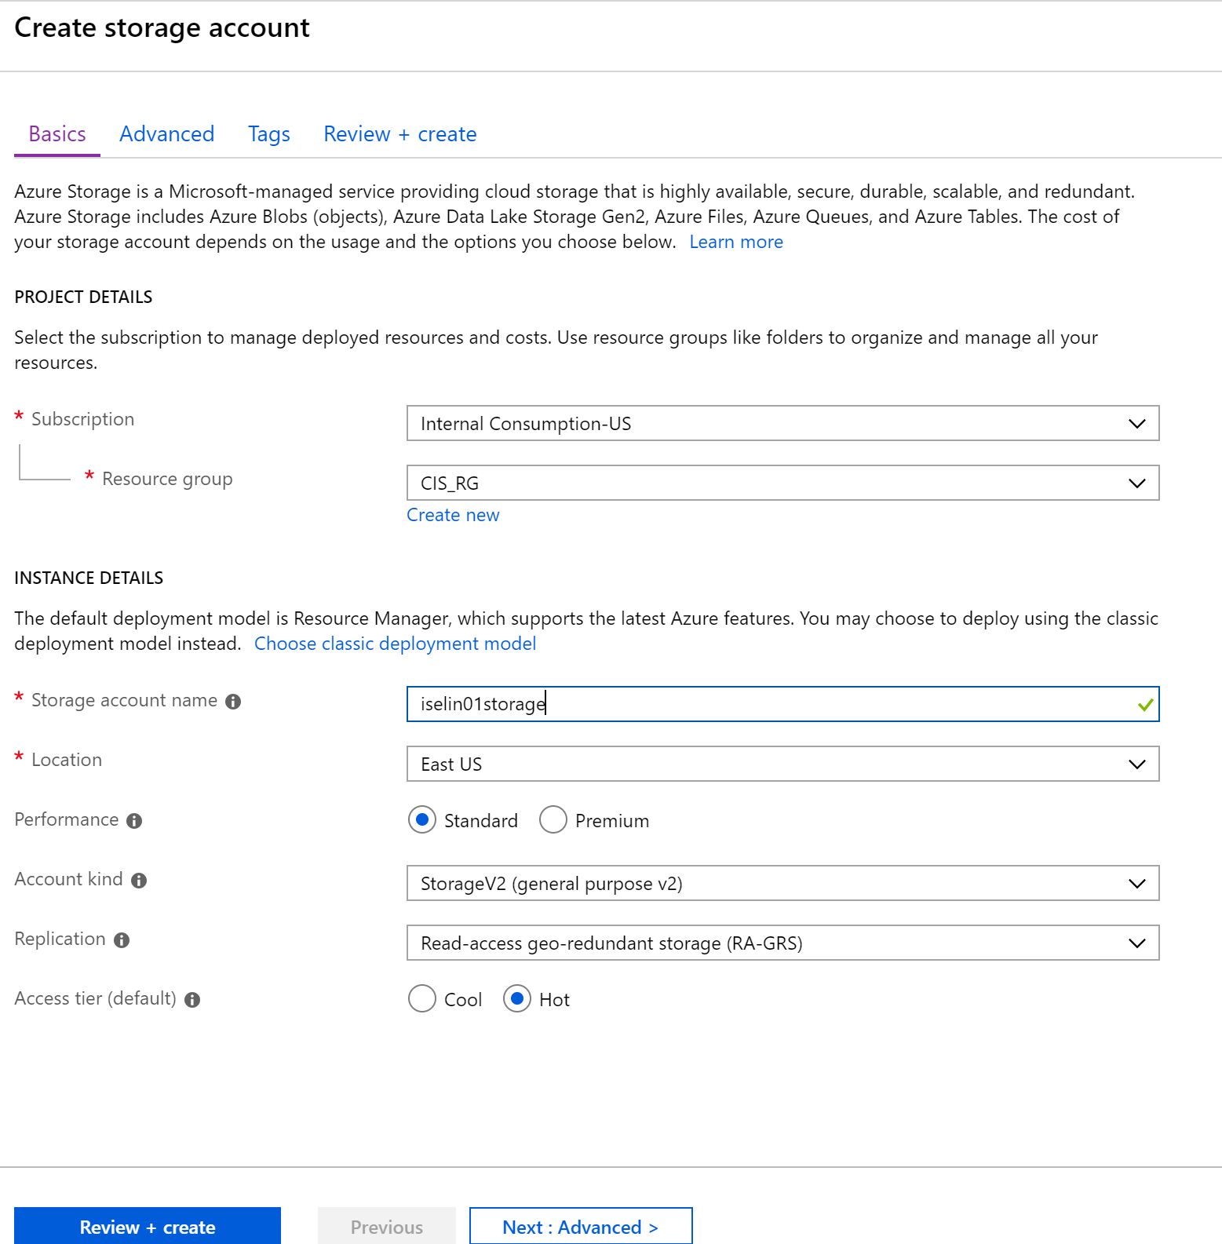

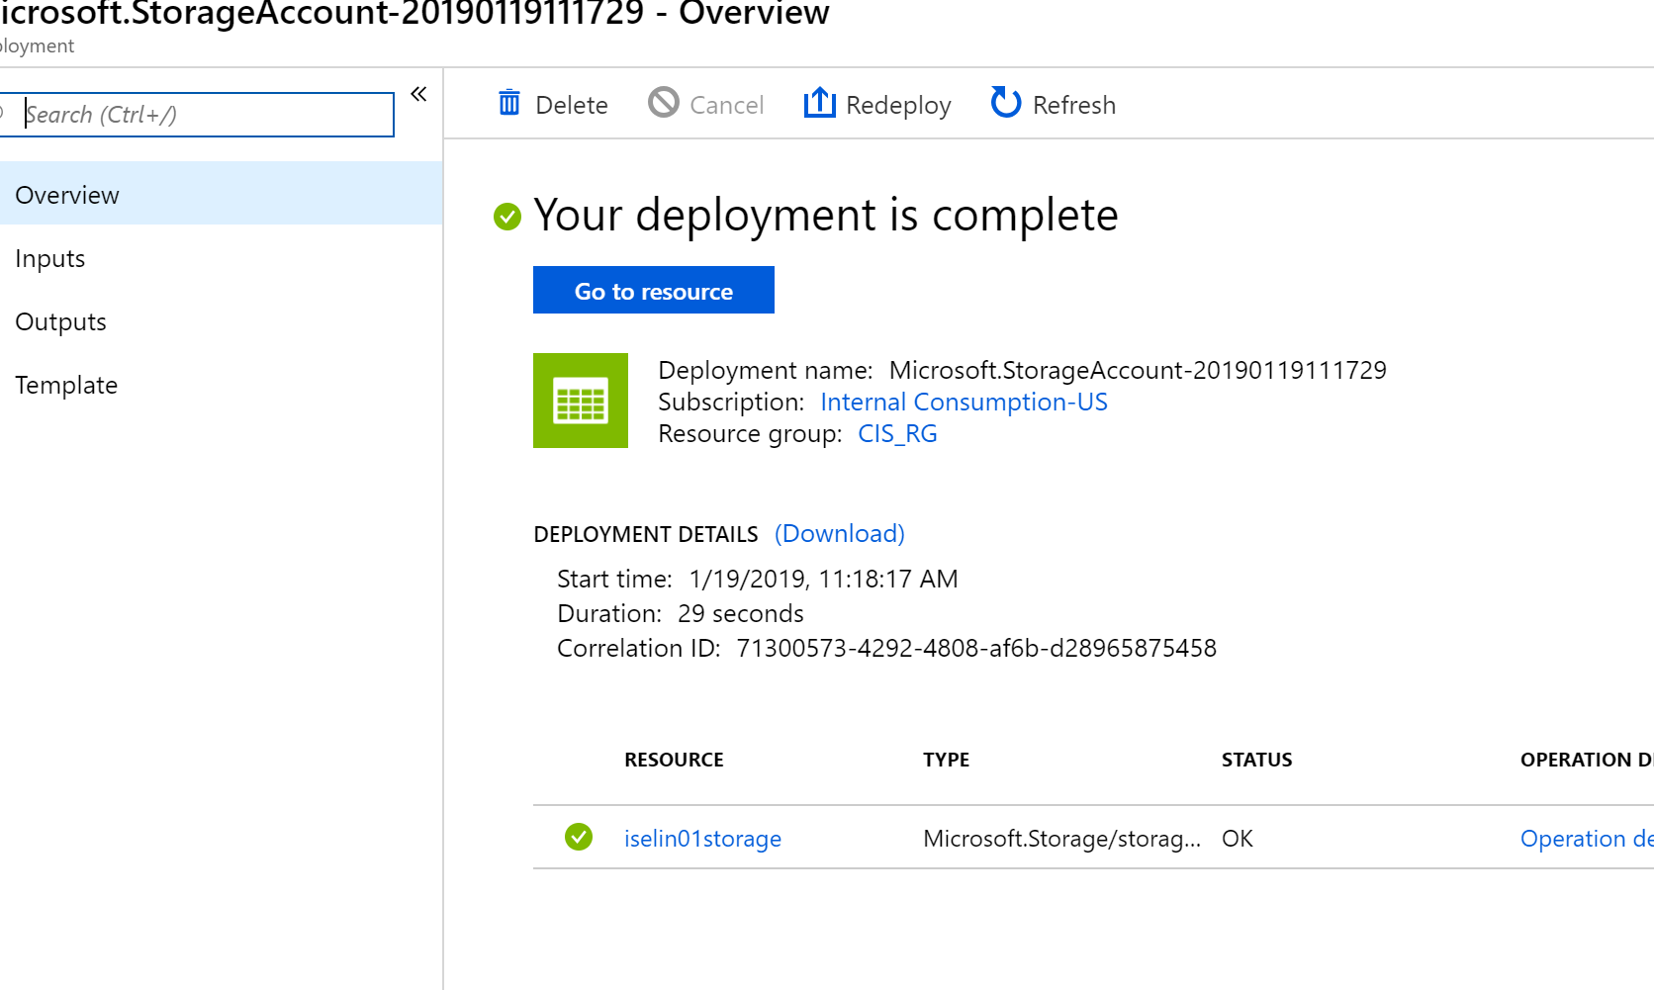

## Steps to create the Azure Blob storage container

1. Click on the Blobs link
2. Add a new container
3. Fill the configuration page like below with your **own information**. **Please not this information for later.**
4. Upload the ClinicalData.csv file to the container

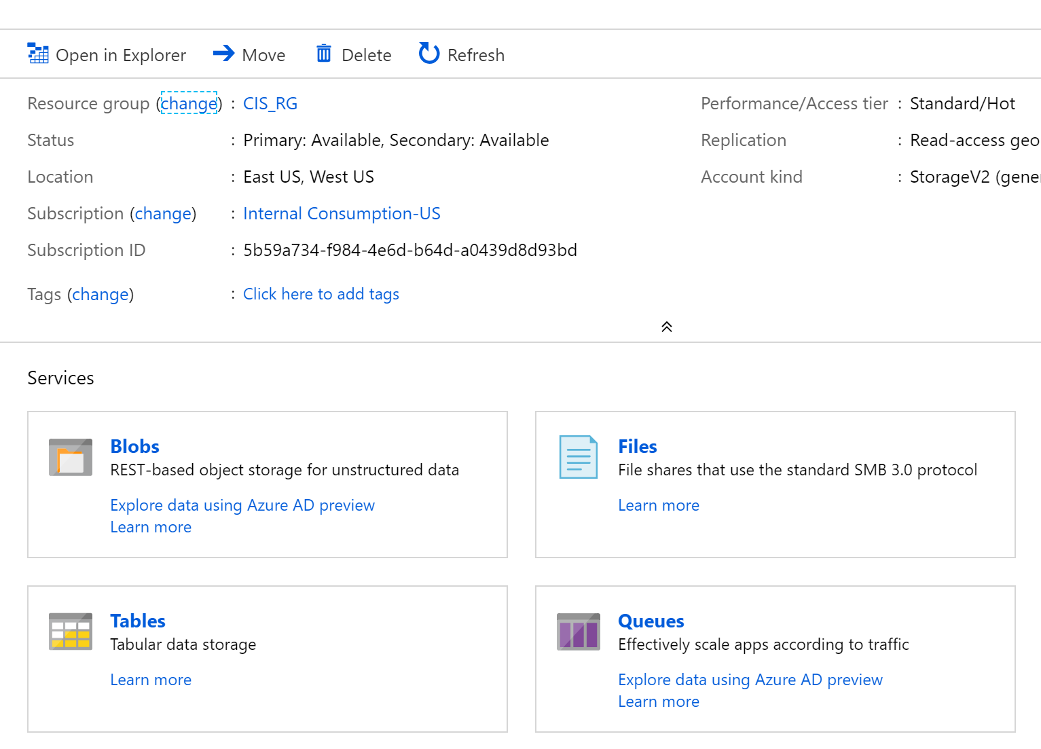

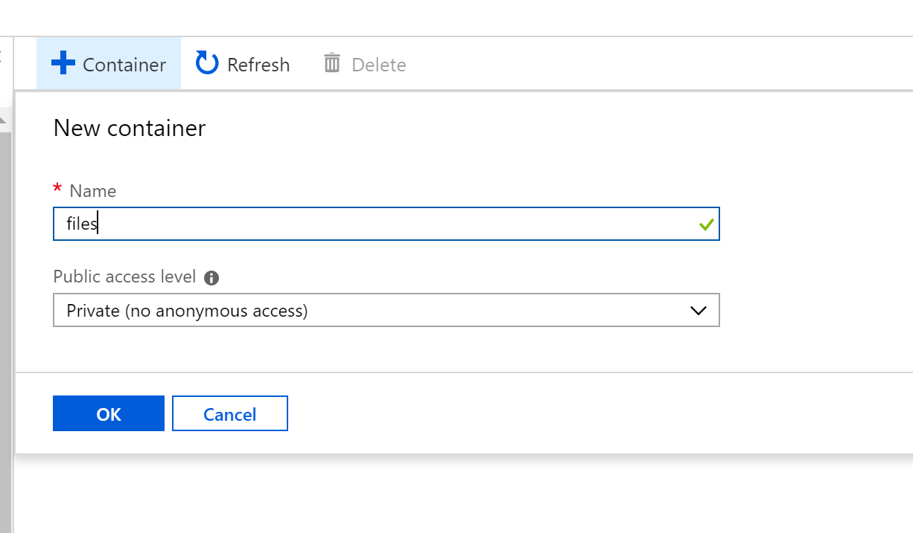

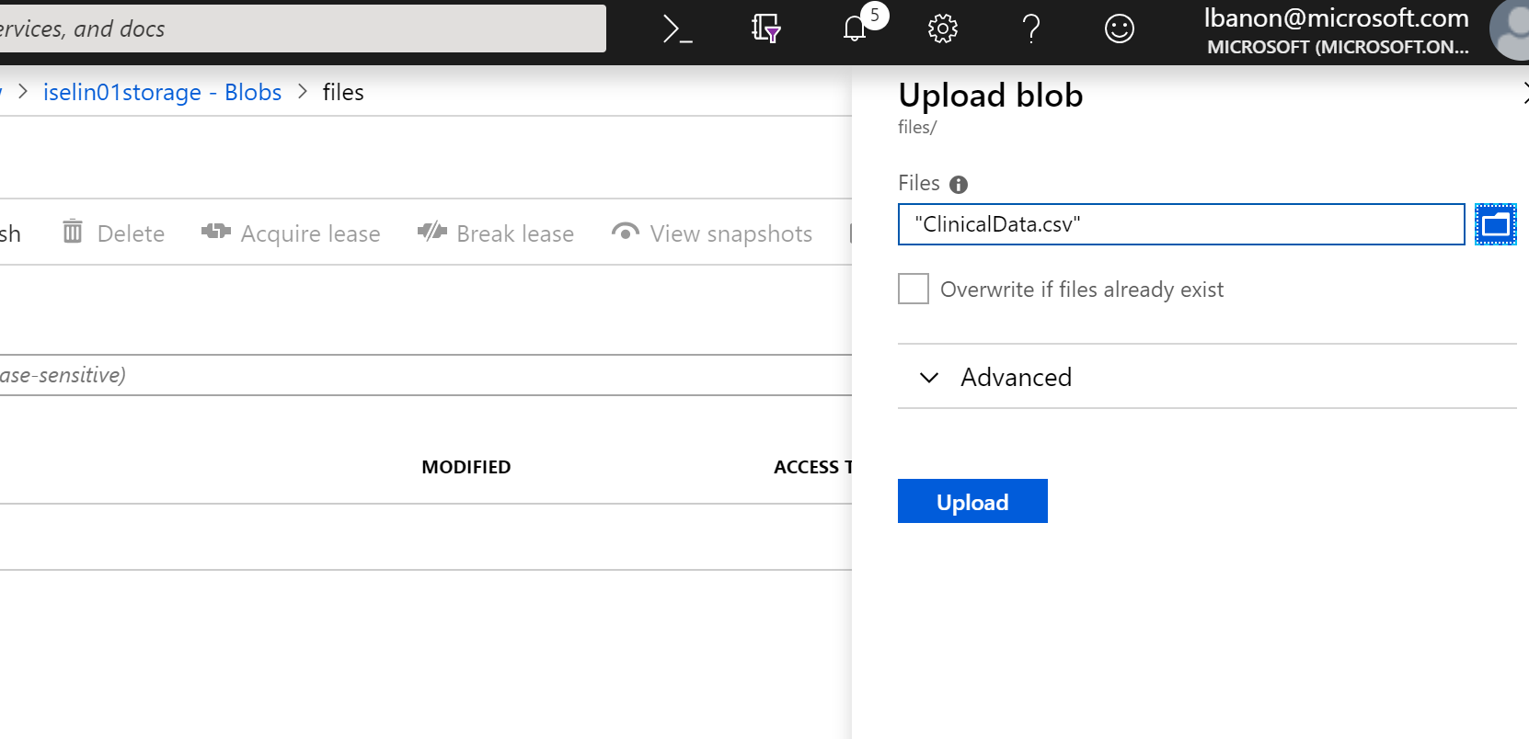

# Part 3 Feeding the Data Warehouse with Azure Data Factory

## Description of the service

Use Azure Data Factory, a globally-deployed data movement service in the cloud, to ingest data from multiple on-premises and cloud sources. Then, connect to on-premises sources with a data management gateway, and use Data Factory to get your data where it needs to go. Prepare and partition your data as you ingest it or apply pre-processing steps

Schedule and manage your data transformation and analysis process. Choose from a wide range of processing services, and put them into managed data pipelines to use the best tool for the job. For example, add a Hadoop processing step for big or semi-structured data, a stored procedure invocation step for structured data, a machine-learning step for analytics, or insert your own custom code as a processing step in any pipeline.

Use data pipelines to transform raw data into finished or shaped data that's ready for consumption by BI tools or applications. Use Data Factory to get your valuable data where it needs to go for consumption by your on-premises or cloud applications and services

Monitor and manage your network of data pipelines at a glance to identify issues and take action. Easily understand when data arrives, where it comes from, and how and when it’s ready for processing. Set up alerts to monitor your overall Data Factory service health. Data Factory saves you time and money by automating your data pipelines with on-demand cloud resource management

## Steps to create the Azure Data Factory

1. On the upper left side of the portal, click on create “plus sign” Create a resource
2. Search for Data Factory
3. Fill the configuration page like below with your **own information**. **Please not this information for later.**

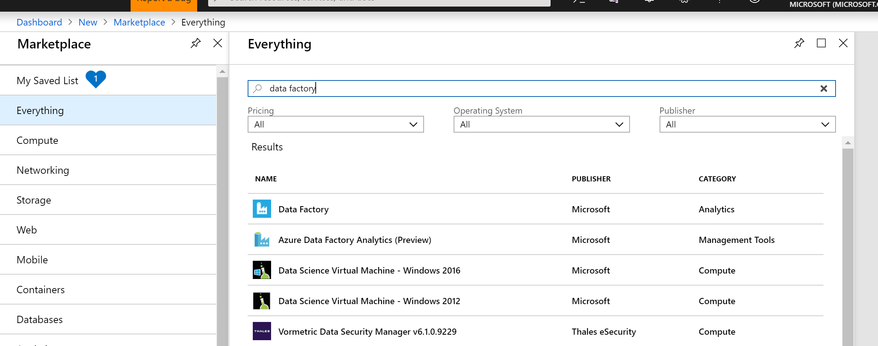

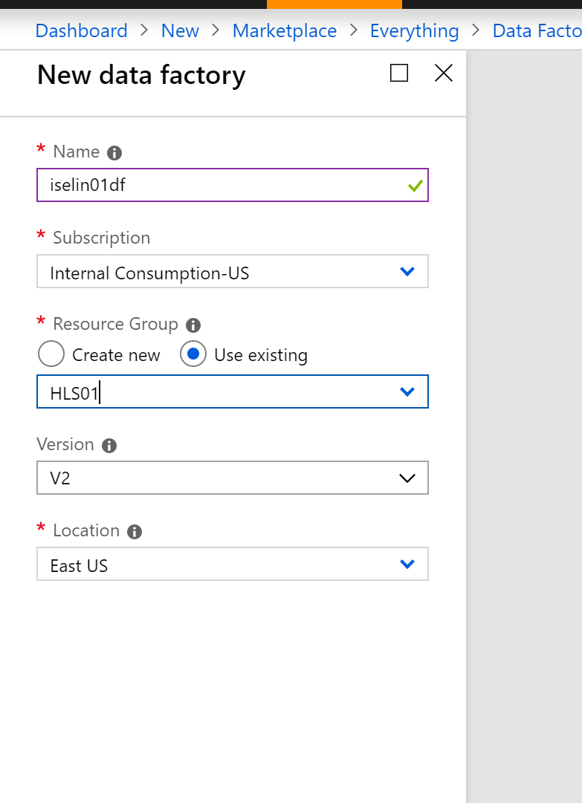

## Steps to create the Azure Data Factory pipeline

1. On the Data Factory page click on “Author&Monitor”
2. We will choose the “Copy Data” wizard
3. We will mapp the source to the csv file we have uploaded and the destination to the Azure Database

